

**T.C.**

**TRAKYA UNIVERSITY**

**ENGINEERING FACULTY**

**MECHANICAL ENGINEERING DEPARTMENT**

**DYNAMIC ANALIZES OF ISOTROPIC BEAMS**

**PROJECT 3**

**Prepared by:**

Ahmet Nadir Keçeci

2100201385

**Advisor:**

Prof. Dr. Taner Tımarcı

January 2017

EDİRNE

# ABSTRACT

The devices we have to use to make our living spaces more comfortable have brought with them problems caused by design errors and insulation deficiencies or by cost-cutting initiatives without considering sound and vibration problems. The easiest and most economical way of noise and vibration isolation is to take the necessary precautions during the project phase and during the installation of the equipment. Both physiological and psychological disturbances, which are caused by the vibrations of the voices that are emitted in two ways, namely the vibration path and the airway, are now emerging as scientific data. Therefore, it is necessary to learn to live with them and to protect them from possible damages, since the series and almost perfect production or mechanics provided by the machines can not be given up. In this project, we will analyze and analyze the findings we have obtained by examining the relation with the mobile support system with the single degree of freedom of vibration control, which has an effective place in the automotive sector.

**Key Words:** Vibration, Insulation, Vibration Control, Mechanical Vibrations, Matlab, Displacement Transmissibility

# PREFACE

First and foremost, I offer my respect and thanks to my dear Assistant Professor Dr.FatihKARAÇAM who has been helping me throughout the entire project and guiding me through his knowledge and opinions.

It is a debt of gratitude to me who has supported me throughout the course of the project and has made this time-efficient and educational for me.

# INDEX

ABSTRACT I

PREFACE III

INDEX IV

SYMBOLS V

FIGURE LIST VI

TABLE LIST VII

1. ENTRANCE 1

1.1. WHAT IS VIBRATION? 1

1.2. IMPORTANCE OF VIBRATION 1

1.3. VIBRATION TYPES 2

2. VIBRATION 3

2.1. DEGREE OF FREEDOM 6

2.2. CLASSIFICATION OF VIBRATION 8

2.2.1. Undamped and damped vibrations 8

2.2.2. Free and forced vibrations 8

2.2.3. Linear and nonlinear vibrations 8

3. VIBRATION ANALYSIS OF BEAMS 9

3.1. SQUARE PROFILE 10

3.1.1. Square Profile Of Cantilever - Cantilever Boundary Condition 10

3.1.2. Square Profile Of Cantilever - Free Boundary Condition 13

3.1.3. Square Profile Of Simple Supported Boundary Condition 16

3.2. I PROFİLE 19

3.2.1. I Profile Of Cantilever - Cantilever Boundary Condition 19

3.2.2. I Profile Of Cantilever - Free Boundary Condition 22

3.2.3. I Profile Of Simple Supported Boundary Condition 25

3.3. T PROFİLE 28

3.3.1. T Profile Of Cantilever - Cantilever Boundary Condition 28

3.3.2. T Profile Of Cantilever - Free Boundary Condition 31

3.3.3. T Profile Of Simple Supported Boundary Condition 34

4. RESULT 37

5. REFERENCES 38

# SYMBOLS

# FIGURE LIST

Figure 1. Spring-mass system with damping element 3

Figure 2. Motion of the spring-mass system 4

Figure 3. Harmonic Motion 4

Figure 4. Simple Pendulum 5

Figure 5. Examples of multi-degree of freedom system 7

Figure 6. Engineering data of all used beams 9

Figure 7. Geometrical representation of total deformation for square profile of cantilever - cantilever boundary condition 10

Figure 8. Geometrical representation of total deformation for square profile of cantilever-free boundary condition 13

Figure 9. Geometrical representation of total deformation for square profile of simple supported boundary condition 16

Figure 10. Geometrical representation of total deformation for I profile of cantilever-cantilever boundary condition 19

Figure 11. Geometrical representation of total deformation for I profile of cantilever-free boundary condition 22

Figure 12. Geometrical representation of total deformation for I profile of simple supported boundary condition 25

Figure 13. Geometrical representation of total deformation for T profile of cantilever-cantilever boundary condition 28

Figure 14. Geometrical representation of total deformation for T profile of cantilever-free boundary condition 31

Figure 15. Geometrical representation of total deformation for T profile of simple supported boundary condition 34

# TABLELIST

Table 1. Frequencies of square profile beam for cantilever-cantilever boundary condition (Hz.) 10

Table 2. Frequencies of square profile beam for cantilever-free boundary condition (Hz.) 13

Table 3. Frequencies of square profile beam for simple supported boundary condition (Hz.) 16

Table 4. Frequencies of I profile beam for cantilever-cantilever boundary condition (Hz.) 19

Table 5. Frequencies of I profile beam for cantilever-free boundary condition (Hz.) 22

Table 6. Frequencies of I profile beam for simple supported boundary condition (Hz.) 25

Table 7. Frequencies of T profile beam for cantilever-cantilever boundary condition (Hz.) 28

Table 8. Frequencies of T profile beam for cantilever-free boundary condition (Hz.) 31

Table 9. Frequencies of I profile beam for simple supported boundary condition (Hz.) 34

# ENTRANCE

## WHAT IS VIBRATION?

Vibration is a periodic motion in which a mass is made at a certain distance at certain time intervals. The distance is called amplitude, and the number of vibrations in one second is called frequency. One of the most important events in vibration control is resonant. Resonance at the working frequency of the device with the natural frequency of vibration of the receiver is when the same time slot at the same frequency. To prevent the occurrence of resonance, the dynamic stiffness of the structure supporting the device must be at least three times that of the vibration damping system. The use of vibration receivers in vibration and shock control has two purposes. One of these; to reduce the effect of the forces on the structure that is placed on the device; the other is to protect the sensitive device which should not be damaged by the movement of the fixed structure.[5]

## IMPORTANCE OF VIBRATION

Most human activities involve vibration in one form or another. For example, we hear because my eardrum is vibrating and seeing, because the waves of light are exposed to vibrations. Respiration is associated with the vibrations of the lungs, and walking involves movement in the legs and hands (periodic). Human speech, larrnations (and tongues) require an oscillatory motion. Scientists in the field of vibration intensified their efforts to develop mathematical theories to understand natural phenomenology and to describe the vibrations of physical systems. Lately, many reviews have been motivated by vibrational engineering applications such as the design of machines, bases, structures, engines, turbines and control systems.[2]

## VIBRATION TYPES

Free vibration is the type of vibration that occurs in systems given an initial motion and then released freely. When a child swings on a swing, pushing and then releasing, or hitting a tuning fork, and then releasing it, are examples of this type of vibration. The mechanical system will then vibrate at its own frequency or own frequencies and it will go to zero. Forced vibration is a type of vibration that occurs when a varying force or motion is applied to a mechanical system. Vibration of the washing machine due to imbalance, vibrations of the vehicle (motordan, from springs or from the road), or vibrations of a building during an earthquake are examples of this vibration. In forced vibration, the frequency of the vibration depends on the frequency of the applied strain or the frequency of movement, but the amplitude of the vibration depends on the mechanical behavior of the system.[6]

# VIBRATION

Vibration can be understood by examining and analyzing the simple mass-spring-damping model. Even a complex structure such as an automobile can be modeled as a sum of simple mass-spring-damping models.

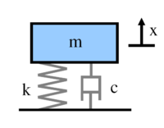

Figure 1. Spring-mass system with damping element

m wherein (m), k (spring constant) and C (damping constant) are members of the vibration system in this place. The force applied to the mass by the spring is proportional to the spring extension "x". The spring force is proportional to the spring deformation.[2-4]



Figure 2. Motion of the spring-mass system



Figure 3. Harmonic Motion

The vibration theory interested in with the oscillatory motion of objects and related forces. The oscillatory motion shown in the above figure is called harmonic motion and is expressed by the following formula.[1]

Where X is the amplitude of the motion, ω is the frequency of motion, and t is the time.

The vibration phenomenon involves the kinetic energy conversion of potential energy and the potential energy conversion of kinetic energy. For this reason, vibrating systems must have elements that store potential energy and kinetic energy. Potential energy storage elements are spring or elastic elements, kinetic energy storage elements are mass or inertia elements.[1]

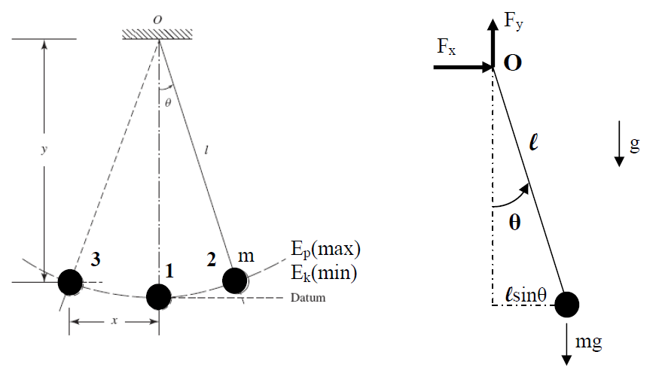

Figure 4. Simple Pendulum

## DEGREE OF FREEDOM

The degree of freedom of a system is the minimum number of independent coordinates needed to identify the positions of any part of the system at any time. The position of the mass in the spring mass system in Fig. 2 can only be expressed by the x coordinate, so that the spring mass system has a single degree of freedom. The motion of the simple sag as given in Fig. 4 can also be expressed by the θ coordinate. However, the pendulum motion can also be defined by the x and y coordinates. But between x and y coordinates there is relation x2 + y2 = L2. This equation is a constraint and x and y are not independent of each other. Therefore, the simple pendulum system has a single degree of freedom.

A multi-degree-of-freedom system can be thought of as a system consisting of points and dampers and pointed masses. In this case the system parameters are discrete and finite. Such systems are called finite dimensional systems or discrete with padded parameter. The following examples illustrate multi-degree of freedom systems.

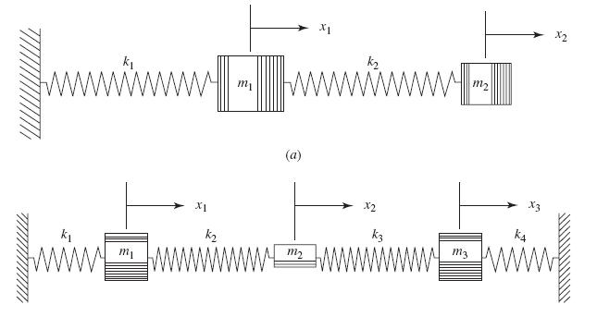



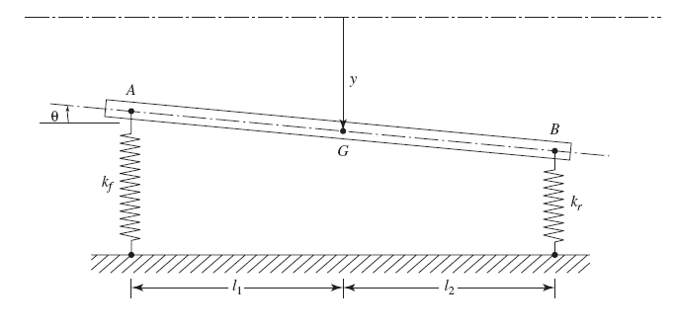



Figure 5. Examples of multi-degree of freedom system

On the other hand, in continuous systems, mass, elasticity and damping are distributed over the system. During vibration, infinite number of point masses can make different movements relative to each other. Such systems are called distributed continuous or infinite dimensional systems.[1]

## CLASSIFICATION OF VIBRATION

### Undamped and damped vibrations

The vibration problem is called undamped if there is no effect on the system due to friction or similar resistances and energy loss and damping. If there is damping in the system, the system is called damped. When examining vibration problems, the solution can be simplified by eliminating the damping, but the damping effects are particularly important for the resonance condition.[1]

### Free and forced vibrations

If the system vibrates due to initial conditions, the system vibrations are called free vibrations. If the system vibrates with external force, the resulting vibrations are called forced vibrations.[1]

### Linear and nonlinear vibrations

If all components of the vibrating system have linear behavior, the formed vibrations are called linear vibrations. If any of the system elements have nonlinear behavior, the formed vibrations are called nonlinear vibrations. Differential equations that express the motion of such systems are in non-linear form. Many vibration systems have non-linear behavior for large vibration amplitudes.[1]

# VIBRATION ANALYSIS OF BEAMS

In this section, we will compare the vibration analysis of profile I, profile T and square profile beams to simple supported, built in-built in and built in-free boundary conditions. All beams used have length of 1 meter and a cross-sectional area of 100 cm2

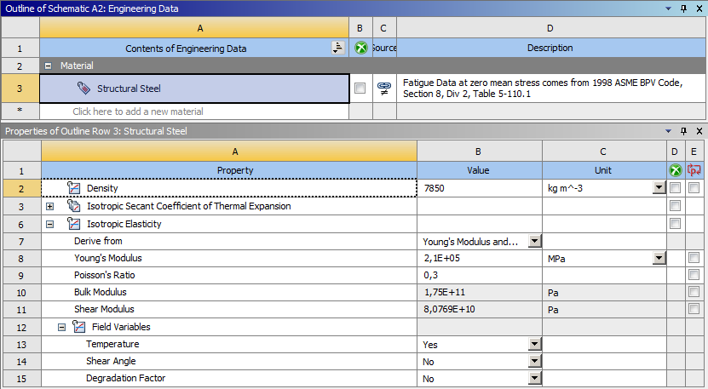

Figure 6. Engineering data of all used beams

## 3.1. SQUARE PROFILE

### 3.1.1. Square Profile Of Cantilever - Cantilever Boundary Condition

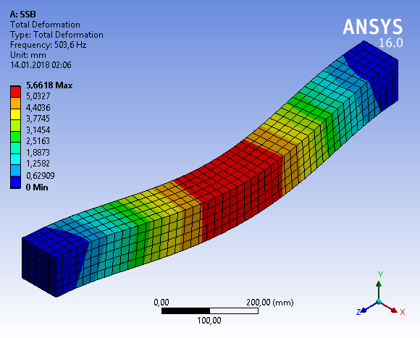

Figure 7. Geometrical representation of total deformation for square profile of cantilever - cantilever boundary condition

Table1. Frequencies of square profile beam for cantilever-cantilever boundary condition (Hz.)

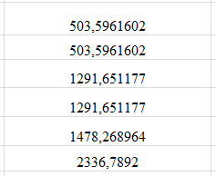

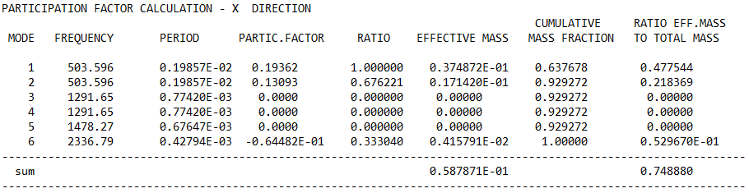

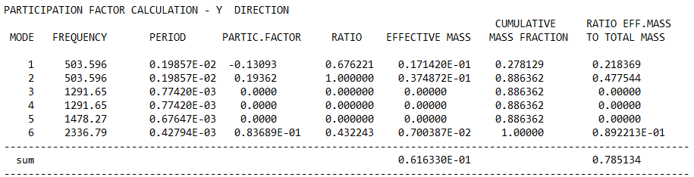

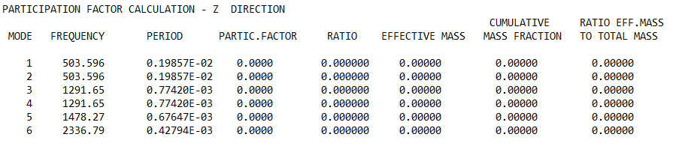

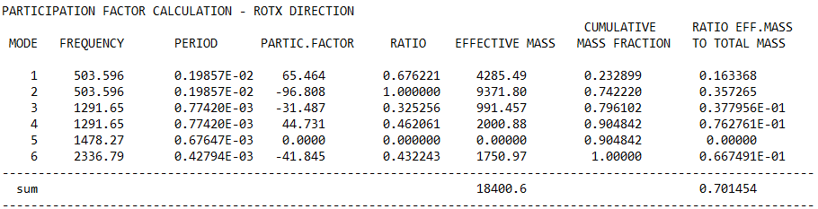

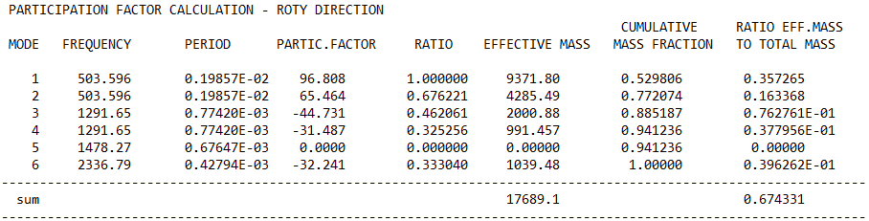

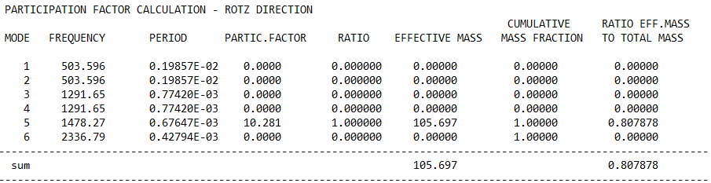

### 3.1.2. Square Profile Of Cantilever- Free Boundary Condition

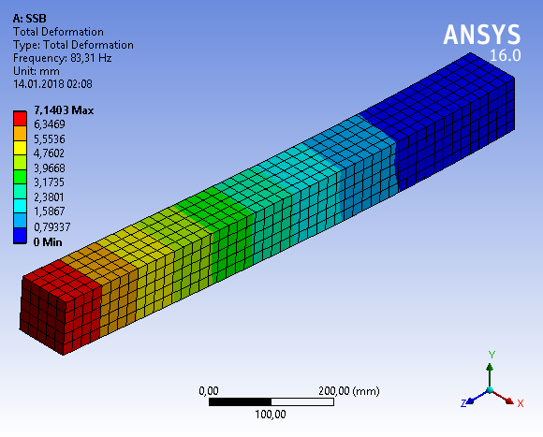

Figure 8. Geometrical representation of total deformation for square profile of cantilever-free boundary condition

Table2. Frequencies of square profile beam for cantilever-free boundary condition (Hz.)

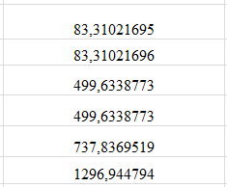

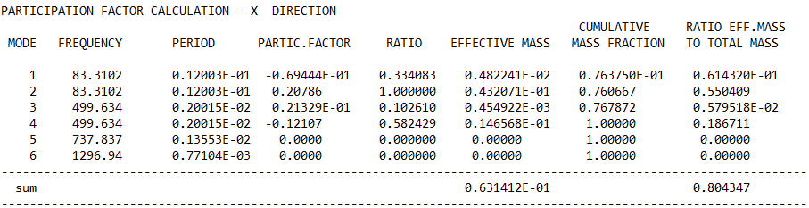

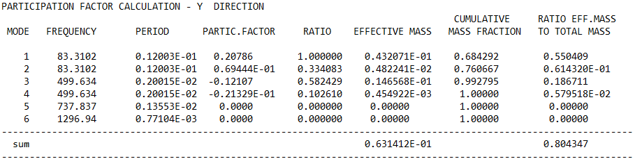

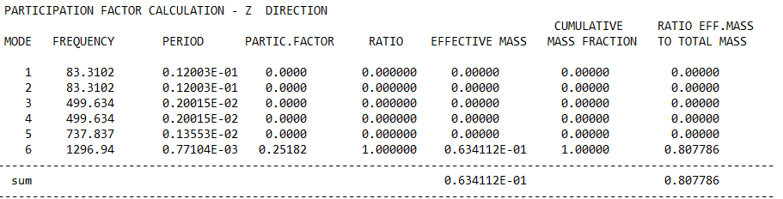

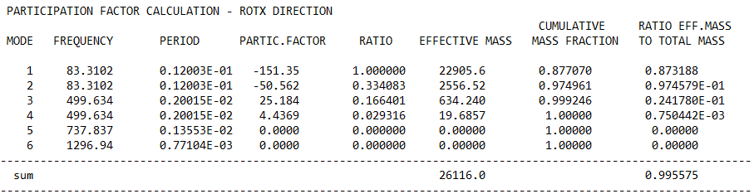

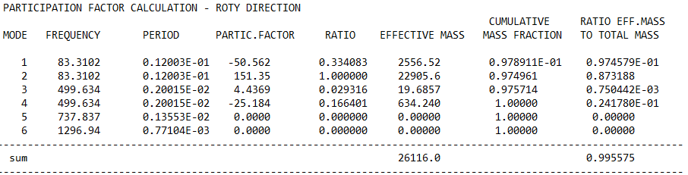

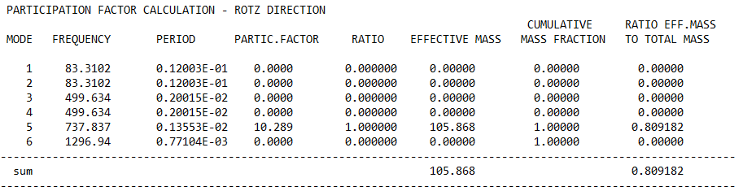

### 3.1.3. Square Profile Of Simple Supported Boundary Condition

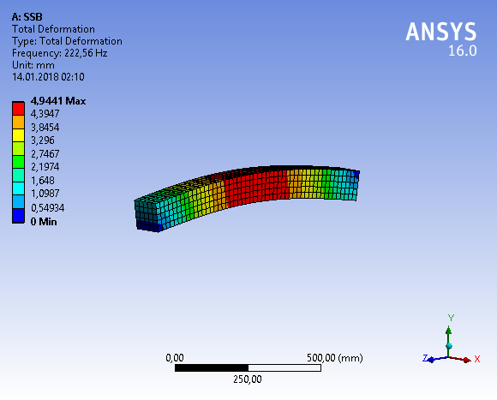

Figure 9. Geometrical representation of total deformation for square profile of simple supported boundary condition

Table3. Frequencies of square profile beam for simple supported boundary condition (Hz.)

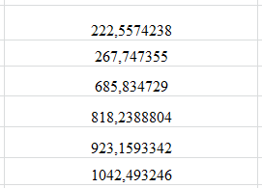

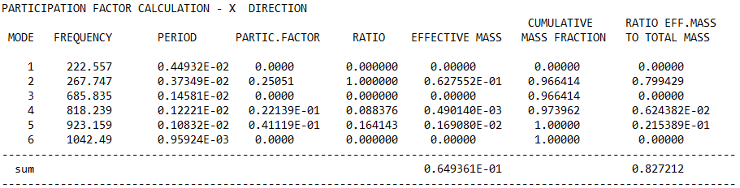

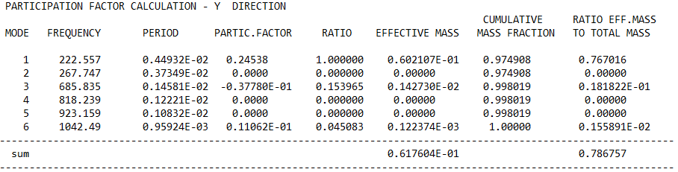

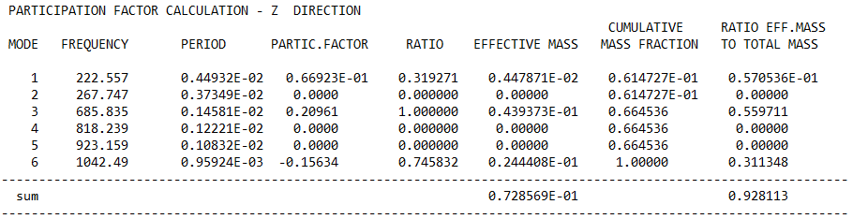

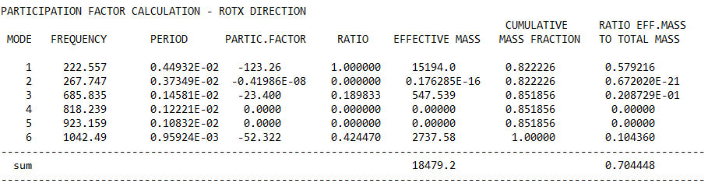

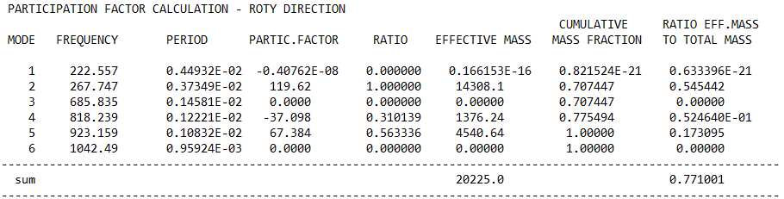

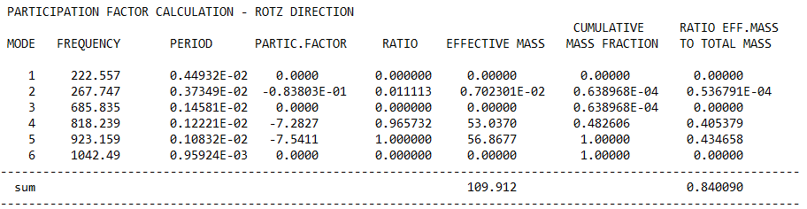

## I PROFİLE

### I **Profile Of** Cantilever - Cantilever**Boundary Condition**

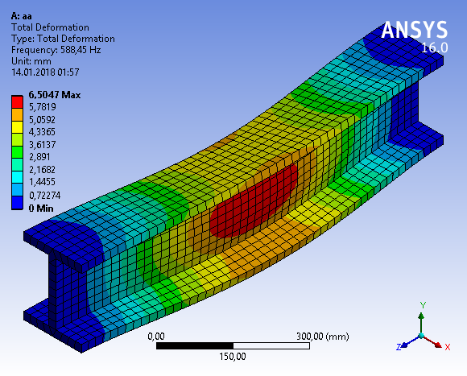

Figure 10. Geometrical representation of total deformation for I profile of cantilever-cantilever boundary condition

Table4. Frequencies of I profile beam for cantilever-cantilever boundary condition (Hz.)

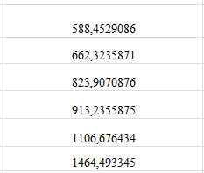

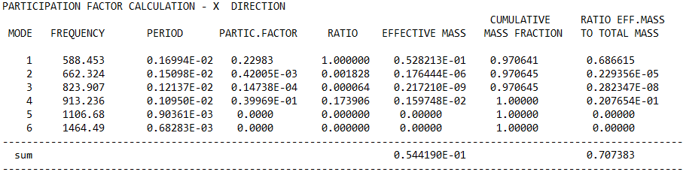

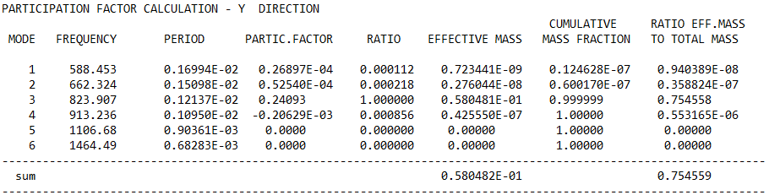

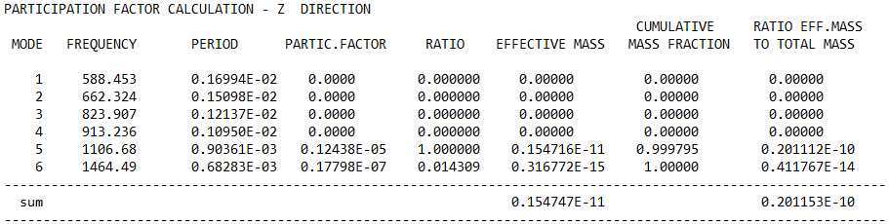

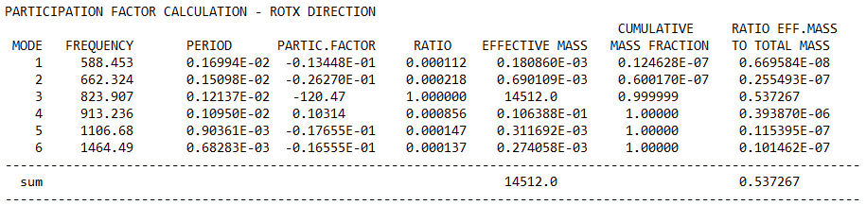

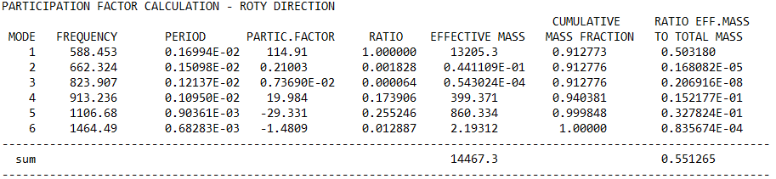

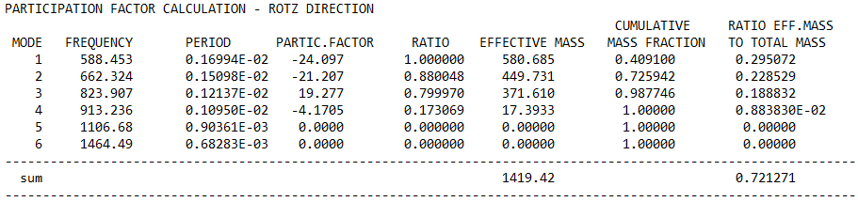

### **I Profile Of** Cantilever - Free **Boundary Condition**

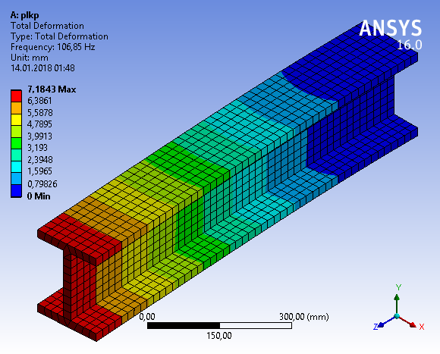

Figure 11. Geometrical representation of total deformation for I profile of cantilever-free boundary condition

Table5. Frequencies of I profile beam for cantilever-free boundary condition (Hz.)

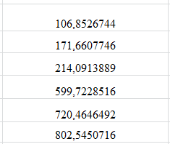

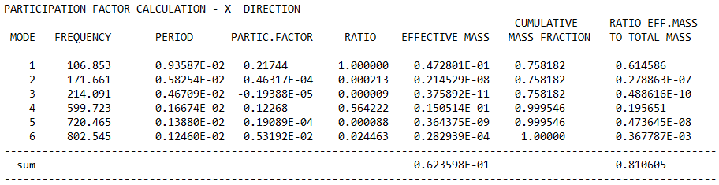

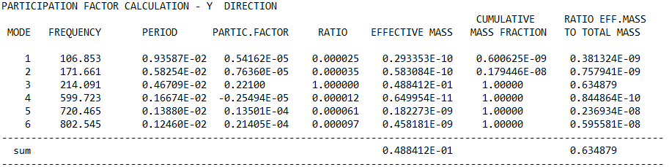

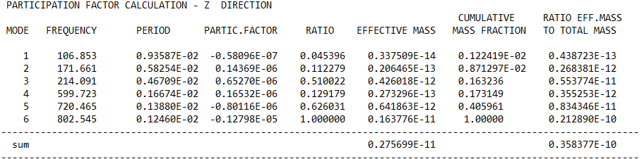

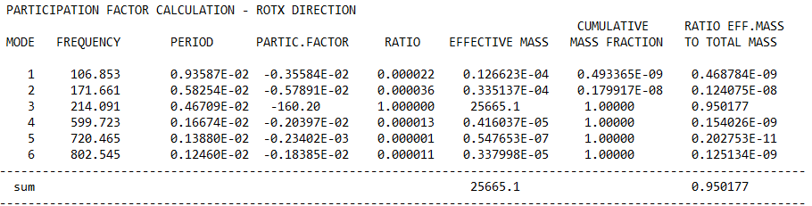

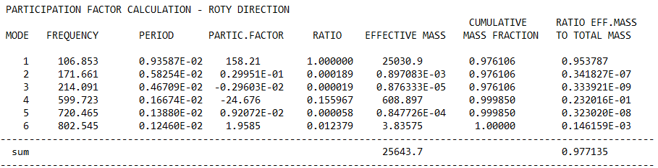

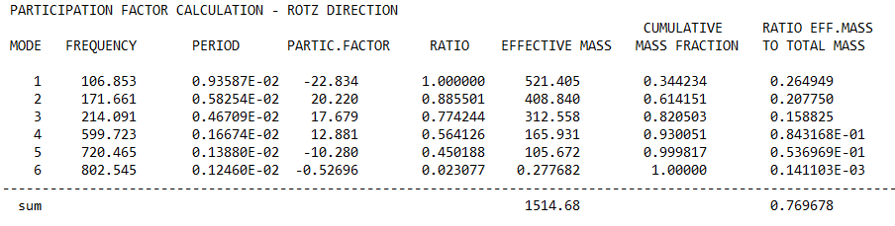

### **I Profile Of** Simple Supported Boundary Condition

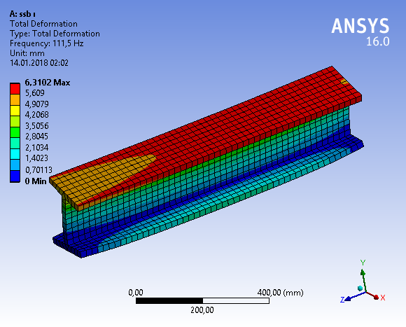

Figure 12. Geometrical representation of total deformation for I profile of simple supported boundary condition

Table6. Frequencies of I profile beam for simple supported boundary condition (Hz.)

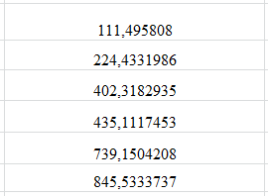

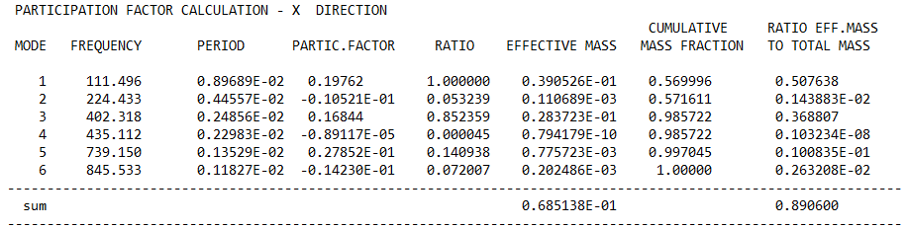

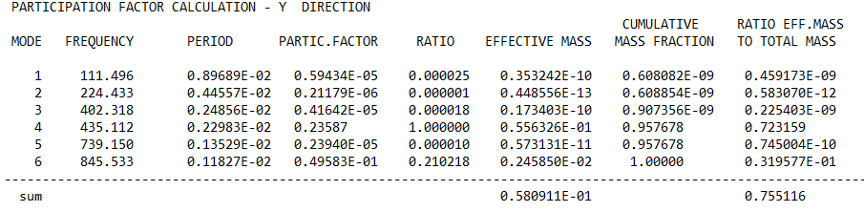

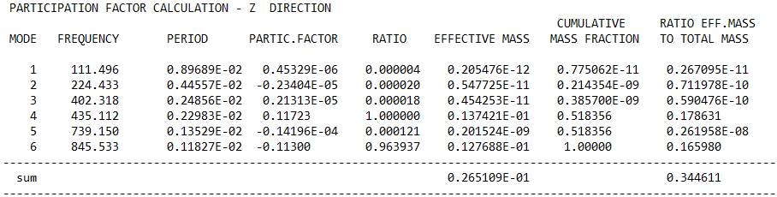

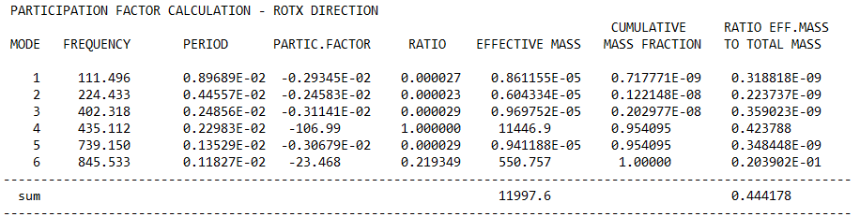

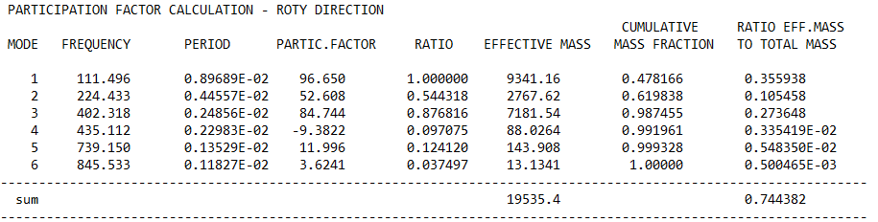

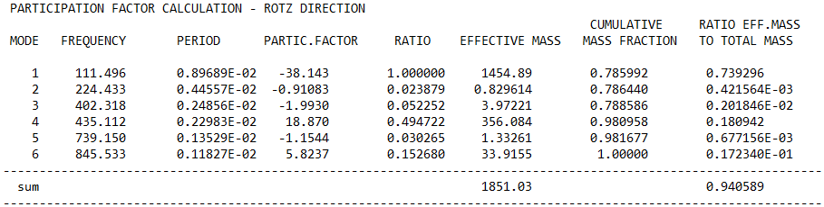

## T PROFİLE

### T **Profile Of** Cantilever - Cantilever**Boundary Condition**

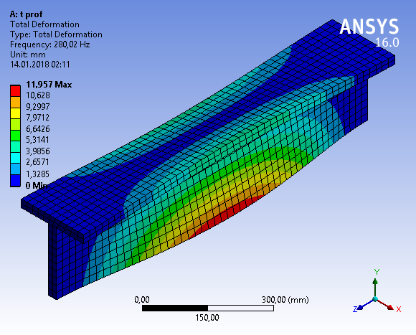

Figure 13. Geometrical representation of total deformation for T profile of cantilever-cantilever boundary condition

Table7. Frequencies of T profile beam for cantilever-cantilever boundary condition (Hz.)

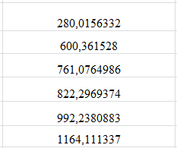

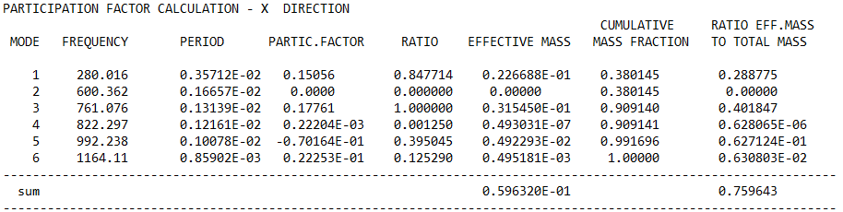

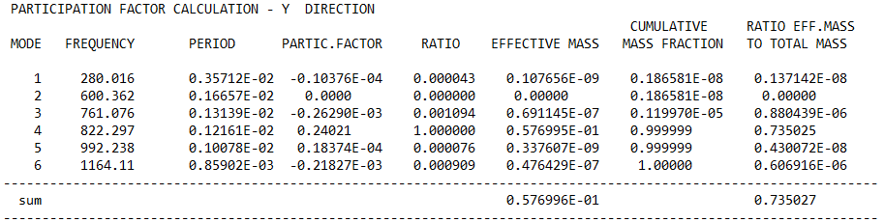

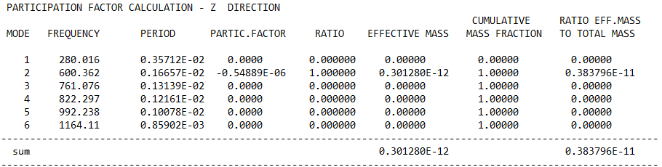

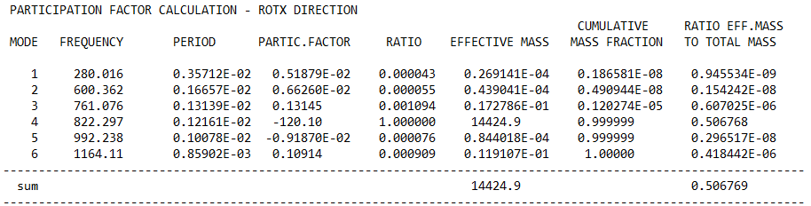

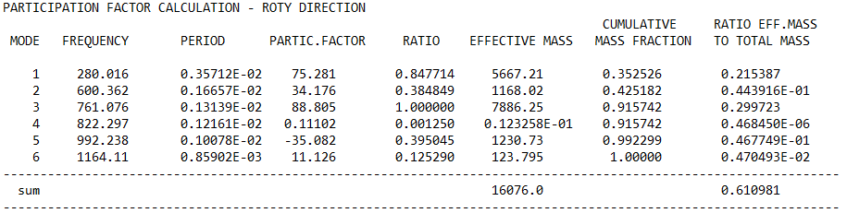

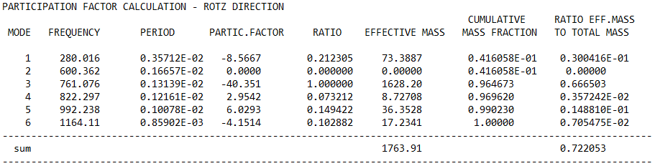

### T **Profile Of** Cantilever - Free **Boundary Condition**

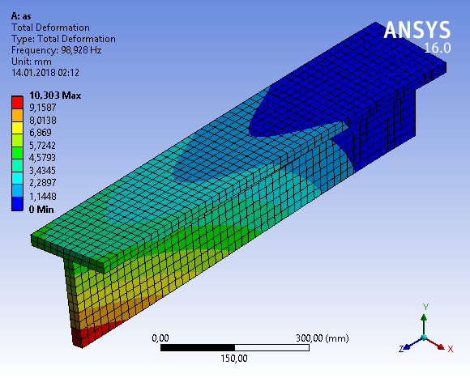

Figure 14. Geometrical representation of total deformation for T profile of cantilever-free boundary condition

Table8. Frequencies of T profile beam for cantilever-free boundary condition (Hz.)

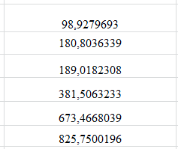

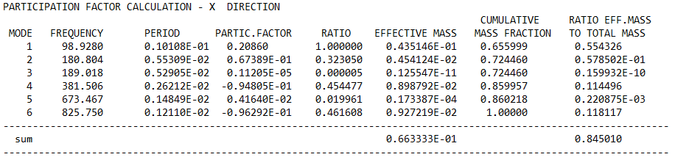

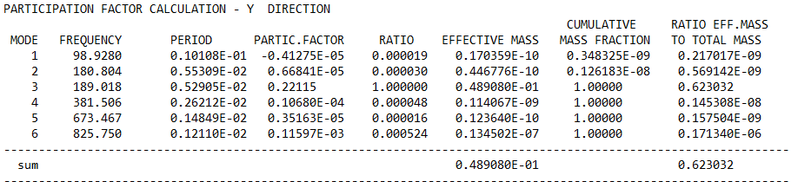

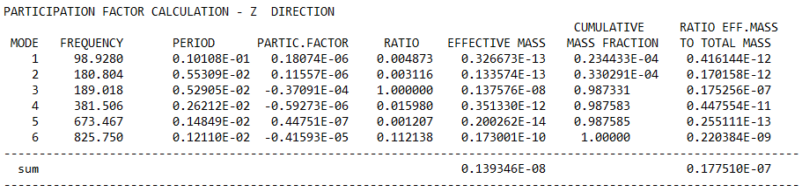

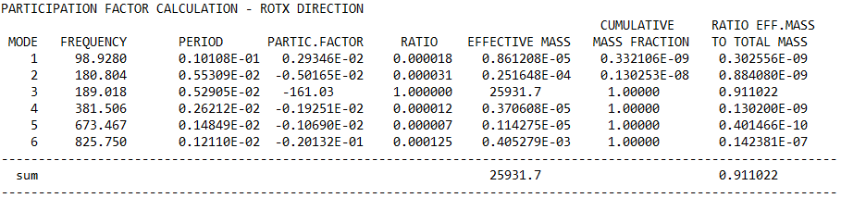

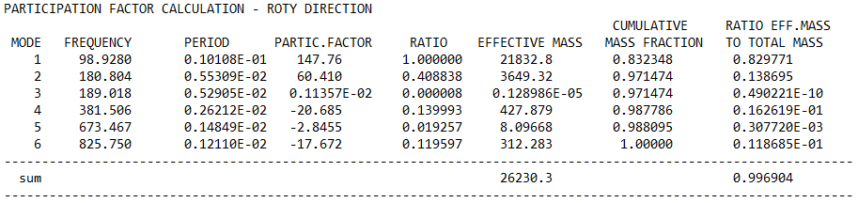

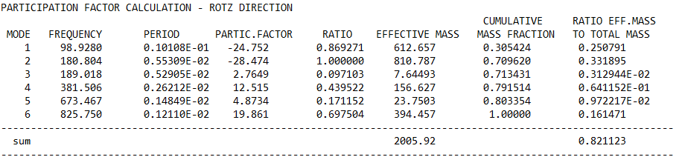

### **T Profile Of** Simple Supported Boundary Condition

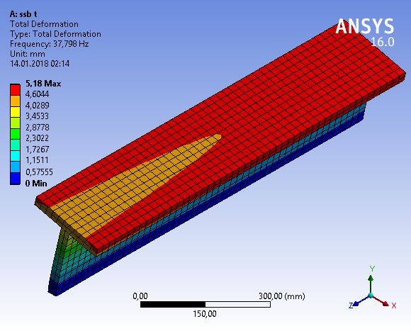

Figure 15. Geometrical representation of total deformation for T profile of simple supported boundary condition

Table9. Frequencies of I profile beam for simple supported boundary condition (Hz.)

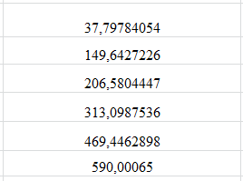

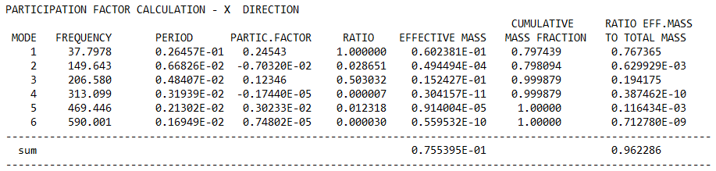

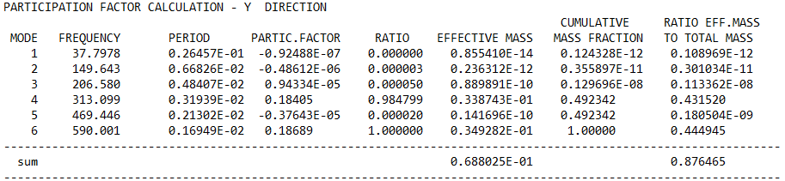

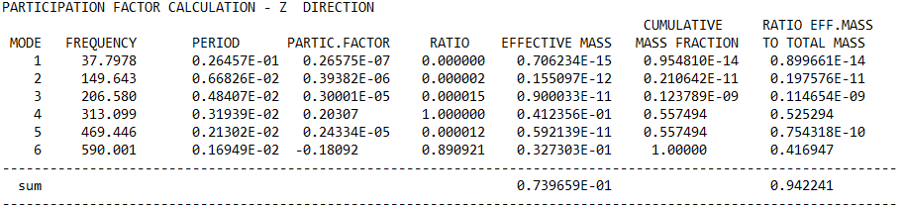

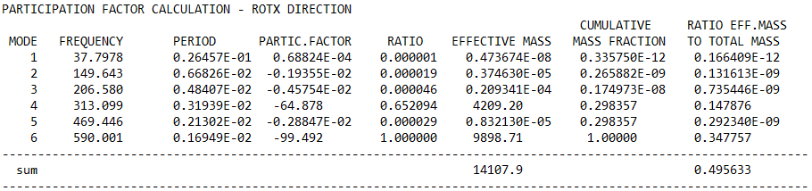

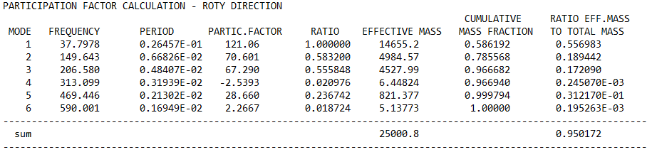

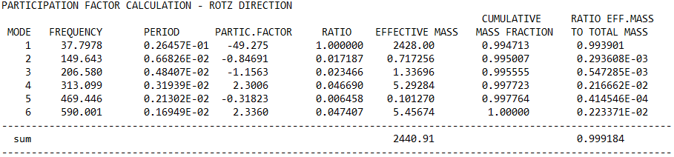

# RESULT

This study compared the vibration results obtained from three different beam profiles with the same cross-sectional areas. Although the cross-sectional areas of these beams are the same, the resulting the frequencies are different because of different moments of inertia.

# 5. REFERENCES

1. Yrd. Doç. Dr. Zeki Kıral - *Mekanik Titreşimler Ders Notları.* İzmir: Dokuz Eylül Üniversitesi.

(kisi.deu.edu.tr/zeki.kiral/Mekanik_Titresimler_Ders_Notları_Zeki_Kıral.pdf)

2. Vikipedi. (2016) - Vibration

3. Singiresu S. Rao. (2011) - *Mechanical.* Miami: Prentice Hall.

4. Taner Tımarcı - Mekanik Titreşimler Ders Notları.

5. https://prezi.com/two8rx6n4ux-/dinamik-titresim-yutucu/

6.Sakarya Üniversitesi – Mekanik Titreşimler Ders Notları (content.lms.sabis.sakarya.edu.tr/Uploads/67527/36890/mek_tit_1.pdf)